**Hexaware Banking System Assignment**

**Name:** Vijaya Lakshmi Punyala

(J525 Vijaya Lakshmi Punyala)

**Task 1:**

1. create database HMBank;
2. create table Customer

(Customer_id int primary key,

First_name varchar(20),

Last_name varchar(20),

Date_of_Birth date,

email varchar(50),

Phone_number int unique key,

adress varchar(100)

);

create table Accounts

(Account_id int primary key,

Customer_id int,

foreign key(Customer_id) references Customers(Customer_id),

Account_Type varchar(20),

Balance decimal(9,2)

);

create table transactions

( transaction_id int primary key,

account_id int,

foreign key(account_id) references Accounts(account_id),

transaction_type varchar(20),

amount decimal(9,2),

transaction_date date

);

1. 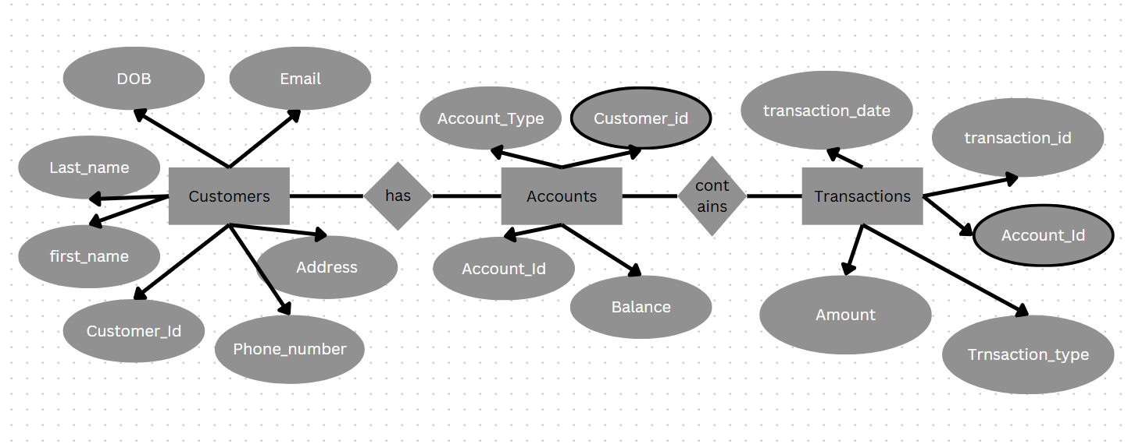

Fig: 1.3. ER Diagrram

**Task 2:**

1 Question:

insert into Customer

values(101, 'Samhita','Rao','2000-07-11','samhita0720rao@gmail.com',987654324,'Gandhi Nagar'),

(102,'Karthik','Vemula','2002-03-23','karthikavemulakv@gmail.com',1234567899,'krishna Street'),

(103,'Harini','Gopal','2005-01-04','harinigopal@gmail.com',876543456,'Lakshmi Colony'),

(104,'Rohan','Chitturi','2001-09-30','rohan2001@gmail.com',876542340,'Ramnagar Colony'),

(105,'Anany','Devulapalli','2004-05-01','anaydevulapalli@gmail.com',987656789,'Srinvasa Apartments'),

(106,'Vijayalakshmi','Punyala','2004-01-23','vijayalaskhmi@gmail.com',765438965,'Sai Residency'),

(107,'Deepak','Cherukuri','2003-05-25','deepakcherukuri@gmail.com',876433398,'Nehru Road'),

(108,'Sunil','Kumar','2004-09-25','sunilkumar@gamil.com',87654329,'Film Nagar'),

(109,'Priya','Rao','2004-12-12','priyaabc@gmail.com',98765432,'Pairs bazar'),

(110,'Sandeep','Varama','2005-03-14','sandeep1234sv@gmail.com',78965436,'Lakshmi Puram');

Insert into accounts

values

(4321, 101, 'Savings Account', 50000.00),

(4322, 102, 'Current Account', 75890.56),

(4323, 103, 'Current Account', 5678.90),

(4324, 104, 'Savings Account', 34000.90),

(4325, 105, 'Savings Account', 60000.00),

(4326, 105, 'Current Account', 6000.78),

(4327, 106, 'Current Account', 7005.56),

(4328, 107, 'Current Account', 8976.76),

(4329, 102, 'Savings Account', 80700.00),

(4330, 103, 'Savings Account', 75000.00),

(4331, 104, 'Current Account', 3000.00),

(4332, 106, 'Savings Account', 200000.00),

(4333, 107, 'Zero_balance', 0.00),

(4334, 102, 'Zero_balance', 0.00),

(4335, 108, 'Savings Account', 80000.00),

(4336, 109, 'Zero_balance', 0.00),

(4337, 110, 'Current Account', 40000),

(4338, 108, 'Current Account', 6000),

(4339, 103, 'Savings Account', 70000);

Insert into transactions

values

(9001, 4331, 'Withdrawal', 100.00, '2022-01-23'),

(9002, 4325, 'Deposit', 1000.00, '2022-02-09'),

(9003, 4322, 'Transfer', 20000.00, '2022-09-21'),

(9004, 4331, 'Withdrawal', 250.00, '2023-04-14'),

(9005, 4324, 'Deposit', 2000.00, '2023-05-25'),

(9006, 4331, 'Transfer', 500.00, '2023-06-22'),

(9007, 4330, 'Withdrawal', 10000.00, '2023-07-01'),

(9008, 4334, 'Transfer', 2000.00, '2023-07-02'),

(9009, 4329, 'Withdrawal', 35000.00, '2023-07-15'),

(9010, 4329, 'Transfer', 10000.00, '2023-08-20'),

(9011, 4323, 'Deposit', 3000.00, '2023-09-30'),

(9012, 4322, 'Withdrawal', 950.00, '2023-11-13'),

(9013, 4321, 'Transfer', 1000.00, '2023-11-20'),

(9014, 4326, 'Transfer', 2000.00, '2024-01-20'),

(9015, 4327, 'Deposit', 3000.00, '2024-01-22'),

(9016, 4327, 'Withdrawal', 1000.00, '2024-01-23'),

(9017, 4338, 'Withdrawal', 300.00, '2024-02-02'),

(9018, 4337, 'Deposit', 6000.00, '2024-02-22'),

(9019, 4336, 'Deposit', 90.00, '2023-02-24'),

(9020, 4325, 'Withdrawal', 8000.00, '2024-03-12');

2 Question:

1. select concat(c.first_name," ",c.last_name) as name,

a.account_type,

c.email from customers c

join accounts a on c.customer_id = a.customer_id;

2. select c.customer_id,

a.account_id,

t.transaction_id,

t.transaction_type,

t.amount,

t.transaction_date from transactions t

inner join accounts a on a.account_id = t.account_id

join customers c on c.customer_id = a.customer_id;

3. select balance*2 from Accounts where account_id = 4332;

4. select concat(First_name," ",Last_name) as full_name from Customers;

5. DELETE FROM transactions WHERE account_id IN

(SELECT account_id FROM accounts WHERE account_type = "zero_balance");

DELETE FROM accounts WHERE account_type = "zero_balance";

6. select * from customers where adress="Lakshmi Colony";

7. select balance from accounts where account_id = 4324;

8. select * from accounts where account_type = "current Account" and balance > 1000.00;

9. select * from transactions where account_id = 4331;

10.select (balance*3.5/100) as Interest from accounts where account_type = "Savings Account";

11.values(4440,102,"Current Account",-500.98),

(4441,105,"Current Account",-2000.90),

(4442,106,"Current Account",-5000.00),

(4443,110,"Current Account",-1.90);

select * from accounts where balance < 0;

12.select * from Customers where adress <> "Lakshmi Colony";

**Task 3:**

1. select avg(balance) from accounts;

2. select * from accounts order by balance desc limit 10;

3. select sum(amount) from transactions where transaction_type="Deposit" and transaction_date between "2022-02-09" and "2023-09-30";

4. (select * FROM Customers order by Date_of_birth asc limit 1)

union all

(select * from Customers order by Date_of_birth desc limit 1);

5. select t.transaction_id,

t.account_id,

a.account_type,

t.transaction_type,

t.amount,

t.transaction_date from transactions t

join accounts a on a.account_id = t.account_id;

6. select c.customer_id,

concat(c.first_name," ",c.last_name) as Full_Name,

Date_of_Birth,

c.email,

c.Phone_number,

c.adress,

a.account_id,

a.account_type,

a.balance from customers c

join accounts a on a.customer_id = c.customer_id;

7. t.account_id,

c.customer_id,

concat(c.first_name," ",c.last_name) as Full_Name,

Date_of_Birth,

c.email,

c.Phone_number,

c.adress,

t.amount,

t.transaction_date from transactions t

inner join accounts a on t.account_id = a.account_id

join customers c on a.customer_id = c.customer_id

where a.account_id = 4331;

8. SELECT c.customer_id,

concat(c.first_name," ",c.last_name) as f_name,

COUNT(a.account_id) AS account_count

FROM Customers c

JOIN Accounts a ON c.customer_id = a.customer_id

GROUP BY c.customer_id, f_name

HAVING COUNT(a.account_id) > 1;

9. SELECT

t.account_id,

SUM(CASE WHEN t.transaction_type = 'Deposit' THEN t.amount ELSE 0 END) AS total_deposits,

SUM(CASE WHEN t.transaction_type = 'Withdrawal' THEN t.amount ELSE 0 END) AS total_withdrawals,

SUM(CASE WHEN t.transaction_type = 'Deposit' THEN t.amount ELSE 0 END) -

SUM(CASE WHEN t.transaction_type = 'Withdrawal' THEN t.amount ELSE 0 END) AS difference

FROM Transactions t

GROUP BY t.account_id;

10. select t.account_id, avg(a.balance) as avg_bal from accounts a

inner join transactions t on a.account_id = t.account_id

where t.transaction_date between "2022-01-23" and "2023-01-23"

group by t.account_id;

11. select account_Type , sum(balance) as total_balance from accounts group by account_Type;

12. select * from accounts order by balance desc;

13. select c.customer_id, concat(c.first_name," ",c.last_name) as Full_name , c.email , a.account_id,a.account_type,a.balance from accounts a

join customers c on a.customer_id = c.customer_id

where balance >50000 ;

14. select account_id, amount, transaction_date, count(*) As duplicate_count

from Transactions

group by account_id, amount, transaction_date

having count(*) > 1;

select * from transactions;

**Task 4:**

1. select c.customer_id,concat(c.first_name," ",c.last_name) as full_name,a.account_id,a.account_type,a.balance from accounts a

join customers c on a.customer_id = c.customer_id

where a.balance = (select max(a.balance) from accounts a)

2. select customer_id, avg(balance)as avg_bal from accounts

where customer_id in(select customer_id from accounts group by customer_id having count(account_id)>1) group by customer_id;

3. select

a.account_id,

a.account_type,

t.transaction_id,

t.transaction_type,

t.amount,

t.transaction_date

from Transactions t

join Accounts a on t.account_id = a.account_id

where t.amount > (select avg(amount) from Transactions);

4. select a.customer_id,a.account_id,a.account_type,

t.transaction_id,t.transaction_type,t.transaction_date,t.amount from transactions t

join accounts a on t.account_id = a.account_id

where t.transaction_id in (select transaction_id from transactions where transaction_id is null);

5. select sum(a.balance) as total_balance from accounts a

left join transactions t on a.account_id = t.account_id

where t.transaction_id (select transaction_id from transactions where transaction_id is null);

6. select c.customer_id,concat(first_name,"",last_name) as full_name,a.account_id,a.account_type,a.balance from accounts a

join customers c on c.customer_id = a.customer_id

where balance in(select min(a.balance) from accounts a);

7. select a.customer_id,

concat(c.first_name, ' ', c.last_name) as full_name

from accounts a

join customers c on a.customer_id = c.customer_id

group by a.customer_id, c.first_name, c.last_name

having count(distinct a.account_type) > 1;

8.

9. select c.customer_id,

concat(first_name," ",last_name) as full_name,

a.account_id,a.account_type,

t.transaction_id,t.transaction_type,t.transaction_date from transactions t

inner join accounts a on a.account_id = t.account_id

inner join customers c on c.customer_id = a.customer_id

where c.customer_id = (select customer_id from customers where customer_id=102);

10. select account_type,

(select sum(balance) from Accounts a2 where a2.account_type = a1.account_type) as total_balance

from Accounts a1

group by account_type;